Test Description: Amazon app test
<Testing the Smoke test of the app>
Test Purpose: <test Amazon app >
Test Run Instructions: <Describe any special instructions needed to execute this test (“Run” phase) >
Test Run Information:  Tester Name: sohayb saleh  Date of Test: 28/01/2024 | Prerequisites for this test: None
Software Versions:
Application: amazon mobile application
Browser: galaxy note 10+
Database: N/A
Operating System: android V12
Required Configuration: [ browser setup, security or user ID roles]
No special setup needed
NOTES and RESULTS:

TEST SCRIPT STEPS/RESULTS
STEP | TEST STEP/INPUT | EXPECTED RESULTS | ACTUAL RESULTS | Requirements Validated | PASS/FAIL
<System Test> <Smoke Test>
 | Click on “Play store” on android system | Play store will open | Play store will open |  | PASS
 | Search “amazon” | Amazon application will  shown | Amazon application will shown |  | PASS
 | Click on “install” | Install the app successfully | Install the app successfully |  | PASS
4. | Hold click on the app | Will appear an uninstall button | An uninstall button shown |  | PASS
5. | Click on “uninstall” | The application will be deleted | The application deleted |  | PASS
6. | Click on “’Amazon Shopping” app | The app run successfully | The app run successfully |  | PASS
7. | Search “mouse pad” | Sub table shown more option | Sub table shown more option 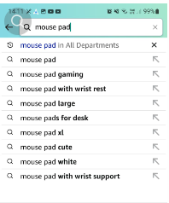 |  | PASS
8. | Click on “mouse pad | Results of mouse pads will shown | Results about mouse pads shown 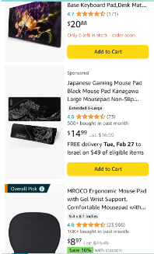 |  | PASS
9. | Click on mouse pad product | Open Detail page of mouse pad | Detail page opens |  | PASS
10. | Scroll down to “add to car” button | Scrolling up/down successfully | Scrolling up/down successfully |  | PASS
11. | Click “Add to Cart” 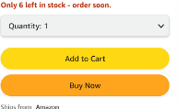 | The product added to cart successfully | The product added to cart successfully 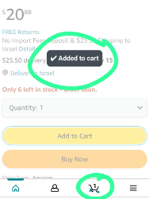
12. | Click on cart icon 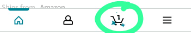 | Cart page open | Cart page opened |  | PASS
13. | Check the product we added | The product we added shown | The product we added shown |  | PASS
14. | Click “procced to checkout”  | Ask you to sign in/up | Login /registration page open |  | PASS
15. | Click on create account | Register page open | Register page open |  | PASS
16. | Enter valid details first and last name”sohayb saleh”, mail”sohaybsaleh@gmail.com”  and pass “So123456” | Navigate to cart page | Navigated to cart page |  | PASS

Test Description: Amazon app test
<Testing the search box of amazon app>
Test Purpose: <test search box of Amazon app >
Test Run Instructions: <Describe any special instructions needed to execute this test (“Run” phase) >
Test Run Information:  Tester Name: sohayb saleh  Date of Test: 28/01/2024 | Prerequisites for this test: None
Software Versions:
Application: amazon mobile application
Browser: galaxy note 10+
Database: N/A
Operating System: android V12
Required Configuration: [ browser setup, security or user ID roles]
No special setup needed
NOTES and RESULTS:

TEST SCRIPT STEPS/RESULTS
STEP | TEST STEP/INPUT | EXPECTED RESULTS | ACTUAL RESULTS | Requirements Validated | PASS/FAIL
<System Test> <Smoke Test>
1. | Check if the search box is present and visible to users | The search box is visible on home page | The search box is visible on home page |  | PASS
2. | Check if the search box accepts input from users | The search box accept inputs from users | The search box accept inputs from users |  | PASS

TEST SCRIPT STEPS/RESULTS
STEP | TEST STEP/INPUT | EXPECTED RESULTS | ACTUAL RESULTS | Requirements Validated | PASS/FAIL
<System Test> <Sanity functional test>
1. | Check the accuracy of the search results enter ”mousepad ” | A page of mouse pads shown not other products | Just mousepads results |  | PASS
2. | Check if there is way to delete the previous input | An (x) mark to delete last input 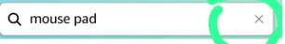 | An (x) mark to delete last input |  | PASS
3. | Check term with spaces ”mouse pad ” | Show results of mouse pads | Show results of mouse pads |  | PASS
4. | Check term with uppercase and lowercase “MouSepAd” | Show results of mouse pads | Show results of mouse pads |  | PASS
5. | Check autofill with not completed word “mou” | Show sub table with autofill of “mou” | Show sub table with completed words 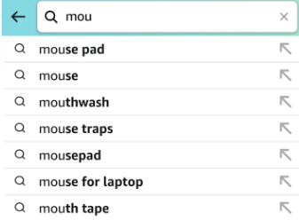 |  | PASS

TEST SCRIPT STEPS/RESULTS
STEP | TEST STEP/INPUT | EXPECTED RESULTS | ACTUAL RESULTS | Requirements Validated | PASS/FAIL
<System Test> <Sanity functional negative test>
1. | Enter random characters “%#$%^” | Show products has near symbols | Show products has near symbols |  | PASS
2. | Enter “jssjuxdeehdhe82uej” | show no result for search | show no result for search 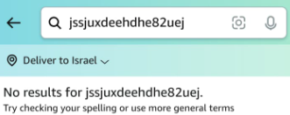 |  | PASS
3. | Search with no term in searchbox | Show an notice or not initiate a search | Not initiate a search |  | PASS
4. | Enter term start with spaces and ends with spaces“ mousepad “ | Show results of “mousepad”  Doesn’t care of start and end’s spaces | Show results of ”mousepad” Doesn’t care of start and end’s spaces |  | PASS
5. | Check response time with unstable network | Show results within short time | Show results within short time |  | PASS
6. | Check if we enters eligible terms “guns” | Has not to show results of guns | Its show results of guns |  | FAIL
7. | Enter term with multiple languages | Show results of English word | Show results of English word |  | PASS
8. | Enter term with other language not English “עכבר” | Show results of mouses  After translate the word | Show results of mouses  After translate the word |  | PASS

TEST SCRIPT STEPS/RESULTS
STEP | TEST STEP/INPUT | EXPECTED RESULTS | ACTUAL RESULTS | Requirements Validated | PASS/FAIL
<System Test> <Usability test>
1. | Check where is the search box displayed | In top of home page (to see it when enter the app) | Its in top of shopping page |  | PASS
2. | Check if there is autocomplete | The search box has auto complete feature | The search box has auto complete |  | PASS
3. | Check if search box has spellcheck | Search box has to give correct words if input not correct | Given many auto complete words correct even if the input not |  | PASS
4. | Check if the search box is usable and available to the users | Work as it should | Work with no bugs |  | PASS

Test Description: Amazon app test
<Testing the search by photo of amazon app>
Test Purpose: <test search by photo of Amazon app >
Test Run Instructions: <Describe any special instructions needed to execute this test (“Run” phase) >
Test Run Information:  Tester Name: sohayb saleh  Date of Test: 28/01/2024 | Prerequisites for this test: None
Software Versions:
Application: amazon mobile application
Browser: galaxy note 10+
Database: N/A
Operating System: android V12
Required Configuration: [ browser setup, security or user ID roles]
No special setup needed
NOTES and RESULTS:

TEST SCRIPT STEPS/RESULTS
STEP | TEST STEP/INPUT | EXPECTED RESULTS | ACTUAL RESULTS | Requirements Validated | PASS/FAIL
<System Test> <functional Test>
1. | Click on search by photo  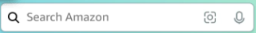 | The app ask user permission to his gallery ,or files | The app ask user to allow access to take pics and record vids |  | PASS
2. | Take pic of mouse  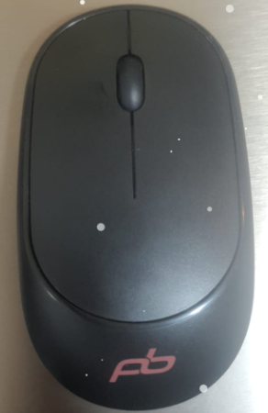 | Should give the user page with results of mouses | Show results of mouses  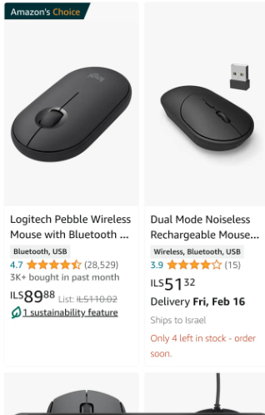 |  | PASS
3. | Check if flash while taking pictures is work=On / not work=off | While flash is off the flash oof the phone wll not work | The flash when its off will not work |  | PASS

TEST SCRIPT STEPS/RESULTS
STEP | TEST STEP/INPUT | EXPECTED RESULTS | ACTUAL RESULTS | Requirements Validated | PASS/FAIL
<System Test> <functional negative Test>
1. | Check what happened if user leave the search by photo open and he not taking action | Give him an popup message | Give the user message and navigate him to the home page 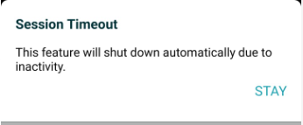 |  | PASS
2. | Check how its behave when taking white photo | Given results of white products | Given results of white paint, white towel. |  | PASS
3. | Check how its behave when taking black photo | Given results of black products | Given results of black paints |  | PASS
4. | Try to take photo while not given access to camera | Should ask the user about access to camera | The app ask user to allow access |  | PASS
5. | Check how the (API) of search by Photo behave when taking picture to multiple products (hat &mouse ) 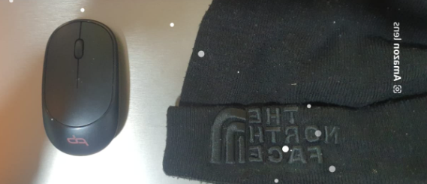 | The app show results of one or both products | Show results of hats 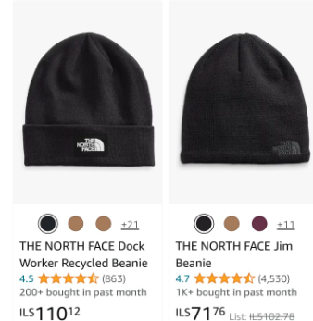 |  | PASS

TEST SCRIPT STEPS/RESULTS
STEP | TEST STEP/INPUT | EXPECTED RESULTS | ACTUAL RESULTS | Requirements Validated | PASS/FAIL
<System Test> <usability Test>
1. | Check the display of the icon of search by photo | Near to the search box .  Not in different page or in the bottom | The icon is in the search box |  | PASS
2. | Check the icon size | Should be visible to the user | Not large and not small its visible to the user |  | PASS

Test Description: Amazon app test
<Testing the filters of amazon app>
Test Purpose: <test filters of Amazon app >
Test Run Instructions: <Describe any special instructions needed to execute this test (“Run” phase) >
Test Run Information:  Tester Name: sohayb saleh  Date of Test: 28/01/2024 | Prerequisites for this test: None
Software Versions:
Application: amazon mobile application
Browser: galaxy note 10+
Database: N/A
Operating System: android V12
Required Configuration: [ browser setup, security or user ID roles]
No special setup needed
NOTES and RESULTS:

TEST SCRIPT STEPS/RESULTS
STEP | TEST STEP/INPUT | EXPECTED RESULTS | ACTUAL RESULTS | Requirements Validated | PASS/FAIL
<Sanity Test> <functional Test>
1. | Click on search and click on mousepad | Going to results of mousepad page | Going to results of mousepad page |  | PASS
2. | Click on filter button 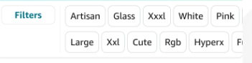 | Open filters page | Filters page opens |  | PASS
3. | From Prime & delivery click on free shipping 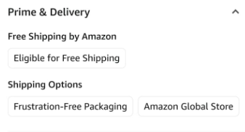 | The show results will be less 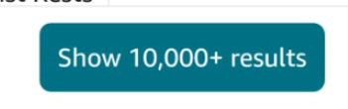 | The show results is less than before click  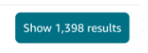 |  | PASS
4. | Check many products delivery | Having free shipping | 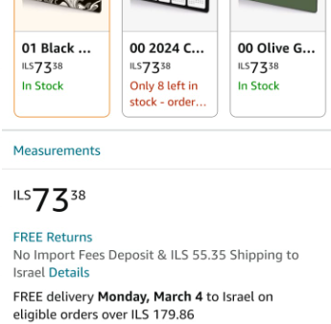 |  | PASS
5. | Click on item length 12 in’ & above  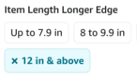 | Show results of mousepads they have 12 in and above with free shipping | Show results of mousepads their length >=12 in 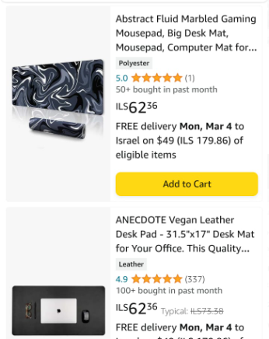 |  | PASS
6. | Click on sort by price : low to high 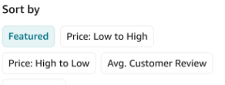 | Show products with lower price to higher one | Show products with lower price to higher one 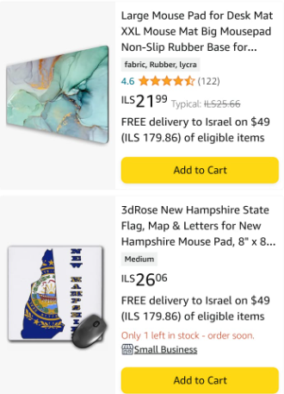 |  | PASS
7. | Click on sort by price : high to low | Show products with high price then lower price | Show products with high price then lower price 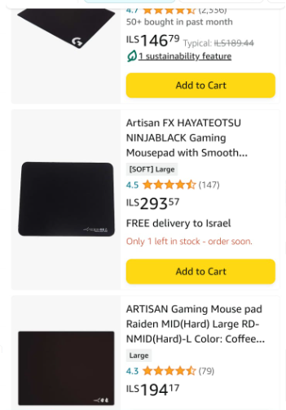 |  | FAIL
8. | Click on clear filters | Show random mousepads products not filtered | Show random mousepads products not filtered |  | PASS

TEST SCRIPT STEPS/RESULTS
STEP | TEST STEP/INPUT | EXPECTED RESULTS | ACTUAL RESULTS | Requirements Validated | PASS/FAIL
<Sanity Test> <functional negative Test>
1. | Click on search mouse pad | Mouse pad results page open | Mouse pad results page open |  | PASS
2. | Click on filters | Filters page opens | Filter page opens |  | PASS
3. | Click on filters frustration-free packaging 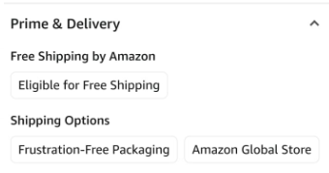 | Show that marked one filters that is frustration-free packaging | Showing that marked two filters frustration-free packaging and office products |  | FAIL
4. | Click on multiple filters from same category 1by1 (all discount ->todays deals)  | The app send a popup message that user should choose on of these filters | The app switch the filter to Today’s Deals   |  | PASS

TEST SCRIPT STEPS/RESULTS
STEP | TEST STEP/INPUT | EXPECTED RESULTS | ACTUAL RESULTS | Requirements Validated | PASS/FAIL
<Sanity Test> <Usability Test>
1. | Check if the filters button is visible to the user | The filters button should be on the top of results page | The filters button is on the top of results page |  | PASS
2. | Check if the filter button is clickable and doing its functionality | Clicking on filters button open filters page | Filter page opens |  | PASS
3. | Check that filters button is readable | Filters button Is readable clearly | Filter button Is readable clearly |  | PASS
4. | Check the filters page easy to use for the users | The filter page should help the user to get his product easier in easier way | The filter page help the user and easy to use |  | PASS

Test Description: Amazon app test
<Testing the sign in of amazon app>
Test Purpose: <test sign in of Amazon app >
Test Run Instructions: <Describe any special instructions needed to execute this test (“Run” phase) >
Test Run Information:  Tester Name: sohayb saleh  Date of Test: 28/01/2024 | Prerequisites for this test: None
Software Versions:
Application: amazon mobile application
Browser: galaxy note 10+
Database: N/A
Operating System: android V12
Required Configuration: [ browser setup, security or user ID roles]
No special setup needed
NOTES and RESULTS:

TEST SCRIPT STEPS/RESULTS
STEP | TEST STEP/INPUT | EXPECTED RESULTS | ACTUAL RESULTS | Requirements Validated | PASS/FAIL
<Sanity Test> <functional Test>
1. | Open the app | The app run | The app run |  | PASS
2. | Click on already have account -sign in | Navigate to sign in page | Sign in page open |  | PASS
3. | Enter the valid mail sohayb.saleh@gmail.com then continue | Open password request page | Open password request page |  | PASS
4. | Enter the valid correct password “So123456” | Navigate to the home page of the app | Navigate to the home page of the app |  | PASS

TEST SCRIPT STEPS/RESULTS
STEP | TEST STEP/INPUT | EXPECTED RESULTS | ACTUAL RESULTS | Requirements Validated | PASS/FAIL
<Sanity Test> <functional negative Test>
1. | Open the app | The app run | The app run |  | PASS
2. | Click on already have account -sign in | Navigate to sign in page | Sign in page open |  | PASS
3. | Enter invalid mail sohayb.salehGmail.com | The app show error message that the email is incorrect check your email | The app show error message that the email is incorrect check your email |  | PASS
4. | Click on continue while email field is empty | Error message will appear  Enter your email | Error message will appear  Enter your email |  | PASS
5. | From SRS check if the email incorrect is the app let the user continue | The app will not let the user continue to enter password and showing error notice | The app will not let the user continue to enter password and showing error notice |  | PASS
6. | After enter valid email sohayb.saleh@gmail.com | Navigate to amazon password page | Navigated to amazon password page |  | PASS
7. | Click on sign in wile password field is empty | An error message will appear to user to enter your password | An error message will appear to user to enter your password |  | PASS
8. | Enter invalid password | An error message will shown | An error message will shown your password incorrect |  | PASS
9. | Check if show password button is showing the password when marked with (v) | The password shows in the pass field | The password shows in the pass field |  | PASS

TEST SCRIPT STEPS/RESULTS
STEP | TEST STEP/INPUT | EXPECTED RESULTS | ACTUAL RESULTS | Requirements Validated | PASS/FAIL
<GUI TEST>
 | Check that there is no spelling error | There is no spelling error in sign In page | There is no spelling error in sign In page |  | PASS
 | Check if there is spelling error with notices | There is no spelling error | There is no spelling error |  | PASS
 | Check if different display screen is ok | -There is no fields or elements disappear .  -There is scroll up/down when minimize the page. | -There is no fields or elements disappear .  -There is scroll up/down when minimize the page. |  | PASS
 | Check if required fields is clear and click on “התחבר” are shown with red notice | Red notice or an error is shown | Red notice is shown |  | PASS
 | Check if all elements and buttons responds to interactions and their functionality | Every button on has to responds to his interaction  (his job) | Every button work as well |  | PASS

TEST SCRIPT STEPS/RESULTS
STEP | TEST STEP/INPUT | EXPECTED RESULTS | ACTUAL RESULTS | Requirements Validated | PASS/FAIL
<Sanity Test> <usability Test>
1. | Open the app | The app run | The app run |  | PASS
2. | Click on already have account -sign in | Navigate to sign in page | Sign in page open |  | PASS
3. | Check if the field is clearly and readable for the user | The fields are readable and clearly to the user | The fields are readable and clearly to the user |  | PASS
4. | Click on continue or sign in while the fields are empty | -Error message will shows  -remined the user to fill the fields (required fields) | -Error message will shows  -remined the user to fill the fields (required fields) |  | PASS

Test Description: Amazon app test
<Testing the sign Up of amazon app>
Test Purpose: <test sign up of Amazon app >
Test Run Instructions: <Describe any special instructions needed to execute this test (“Run” phase) >
Test Run Information:  Tester Name: sohayb saleh  Date of Test: 28/01/2024 | Prerequisites for this test: None
Software Versions:
Application: amazon mobile application
Browser: galaxy note 10+
Database: N/A
Operating System: android V12
Required Configuration: [ browser setup, security or user ID roles]
No special setup needed
NOTES and RESULTS:

TEST SCRIPT STEPS/RESULTS
STEP | TEST STEP/INPUT | EXPECTED RESULTS | ACTUAL RESULTS | Requirements Validated | PASS/FAIL
<Sanity Test> <functional Test>
1. | Open the app | The app run | The app run |  | PASS
2. | Click on create an account | Navigate to sign up page | Sign up page open |  | PASS
3. | Fill the fields  - first and last name “sohayb saleh”  -email sohayb.saleh@gmail.com  -create password “So123456”  Click on continue | Navigate to verify mail address and the app send OTP code to the mail | Navigate to verify mail address and the app send OTP code to the mail |  | PASS
4. | Fill the enter OTP code field and click create your amazon account | Navigate to home page | Navigate to home page |  | PASS
5. | Click on continue while all fields are empty | Showing red error message with marked required field | Showing red error message with marked required field |  | PASS
6. | Fill the password field with the show password checkbox is marked | Showing the character that user enter in the password field | Showing the character that user enter in the password field |  | PASS

STEP | TEST STEP/INPUT | EXPECTED RESULTS | ACTUAL RESULTS | Requirements Validated | PASS/FAIL
<Sanity Test> <functional negative Test>
1. | Open the app | The app run | The app run |  | PASS
2. | Click on create an account | Navigate to sign up page | Sign up page open |  | PASS
3. | Click on continue while all fields are empty | Showing red error message with marked required field | Showing red error message with marked required field |  | PASS
4. | Fill the first name and last name with numbers | The app allow the user to sign up with name of numbers only | The app allow the user to sign up with name of numbers only |  | PASS
5. | Fill the email field with invalid mail  Sohaybsaleh | Error message will shown | Error message will shown |  | PASS
6. | Fill the email field with invalid mail  Sohaybsaleh@.com | Error message will shown | Error message will shown |  | PASS
7. | Fill the email field with invalid mail  Sohaybsalehgmail.com | Error message will shown | Error message will shown |  | PASS
8. | Fill the email field with invalid mail  sohaybsaleh@gmasol.com | Error message will shown | Error message will shown |  | PASS
9. | Fill the password field with short pass | Error message will shown | Error message will shown  Pass must be at least 6 char |  | PASS
10. | Fill the password field with serial pass “123456” | An error message will shown that your pass not strong | The app let the user sign up with weak pass |  | FAIL
11. | fill the first last name field while email & pass are empty | Error message will shown | Error message will shown  1 for the email  2 for the pass |  | PASS
12. | fill the first last name and email field while password is empty | Error message will shown | Error message will shown enter your password |  | PASS
13. | Fill the first name last name and password fields while mail is empty | Error message will shown | Error message will shown  Enter you email |  | PASS
14. | Fill the verify code invalid code | Error message will shown | Invalid OTP.please check your code and try again |  | PASS

STEP | TEST STEP/INPUT | EXPECTED RESULTS | ACTUAL RESULTS | Requirements Validated | PASS/FAIL
<Sanity Test> <Boundary Test>
1. | Fill the firstname with one letter “s” | Register successfully | Register successfully |  | PASS
2. | Fill the lastname with one letter “s” | Register successfully | Register successfully |  | PASS
3. | First name and Last name have zero letters | Error /red notice is shown | Error /red notice is shown |  | PASS
4. | Phone number has zero digits | Error /red notice is shown | Error /red notice is shown |  | PASS
5. | Fill the phone number with 1-9 digits | The error is shown | The error is shown |  | PASS
6. | Password has zero chars | Error /red notice is shown | Error /red notice is shown |  | PASS
7. | Fill the password with 1-5 digits | Red notice is shown with min limit for password | Red notice is shown with min limit for password |  | PASS

STEP | TEST STEP/INPUT | EXPECTED RESULTS |  | ACTUAL RESULTS | Requirements Validated | PASS/FAIL
<Gui Test>
1. | Check that is the spellings of the sign up page are correct |  | There is no error of spelling | There is no error of spelling |  | PASS
2. | Check if there is spelling error with notices |  | There is no error of spelling | There is no error of spelling |  | PASS
3. | Check if required fields is clear and click on “continue” are shown with red notice |  | An error message will shown | An error message will shown |  | PASS
4. | Check if all elements and buttons responds to interactions and their functionality |  | Every button on has to responds to his interaction  (his job) | Every button on has to responds to his interaction  (his job) |  | PASS

STEP | TEST STEP/INPUT | EXPECTED RESULTS | ACTUAL RESULTS | Requirements Validated | PASS/FAIL
<Usability Test>
1. | Check if the required field is marked and easy to user to notice them | The required fields are marked with red board | The required fields are marked with red board |  | PASS
2. | Check if every button in the page is clickable and work as his function | Every button clickable and work as his func | Every button clickable and work as his func |  | PASS

Test Description: Amazon app test
<Testing the settings of amazon app>
Test Purpose: <test Settings of Amazon app >
Test Run Instructions: <Describe any special instructions needed to execute this test (“Run” phase) >
Test Run Information:  Tester Name: sohayb saleh  Date of Test: 28/01/2024 | Prerequisites for this test: None
Software Versions:
Application: amazon mobile application
Browser: galaxy note 10+
Database: N/A
Operating System: android V12
Required Configuration: [ browser setup, security or user ID roles]
No special setup needed
NOTES and RESULTS:

TEST SCRIPT STEPS/RESULTS
STEP | TEST STEP/INPUT | EXPECTED RESULTS | ACTUAL RESULTS | Requirements Validated | PASS/FAIL
<Sanity Test> <functional Test>
1. | Open the setting button (feature) | A dropdown table will shown | A dropdown table will shown 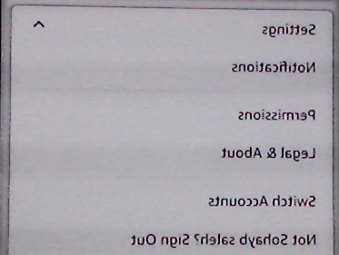 |  | PASS
2. | Click on notifications | Navigate to notification page | Navigate to notification page 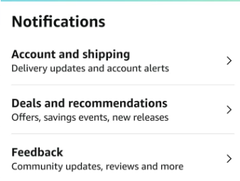 |  | PASS
3. | Click on permission | Navigate to permission page | Navigate to permission page |  | PASS
4. | Click on legal & about | Navigate to legal & about page | Navigate to legal & about page |  | PASS
5. | Click on switch account | Navigate to switch account page | Navigate to switch account page |  | PASS
6. | Click on sign out | Sign out of the current user and navigate to asking the user to sign in or sign up to the app | Sign out of the current user and navigate to asking the user to sign in or sign up to the app |  | PASS
7. | Click on country & language | Navigate to country & language | Navigate to country & language and ask the user about currency he want to use |  | PASS

STEP | TEST STEP/INPUT | EXPECTED RESULTS | ACTUAL RESULTS | Requirements Validated | PASS/FAIL
<Usability Test>
1. | Check if every button in the page is clickable and work as his function | Every button clickable and work as his func | Every button clickable and work as his func |  | PASS

STEP | TEST STEP/INPUT | EXPECTED RESULTS |  | ACTUAL RESULTS | Requirements Validated | PASS/FAIL
<Gui Test>
1. | Check that is the spellings of the sign up page are correct |  | There is no error of spelling | There is no error of spelling |  | PASS
2. | Check if all elements and buttons responds to interactions and their functionality |  | Every button on has to responds to his interaction  (his job) | Every button on has to responds to his interaction  (his job) |  | PASS

Test Description: Amazon app test
<Testing the Add to cart of amazon app>
Test Purpose: <test Add to cart of Amazon app >
Test Run Instructions: <Describe any special instructions needed to execute this test (“Run” phase) >
Test Run Information:  Tester Name: sohayb saleh  Date of Test: 28/01/2024 | Prerequisites for this test: None
Software Versions:
Application: amazon mobile application
Browser: galaxy note 10+
Database: N/A
Operating System: android V12
Required Configuration: [ browser setup, security or user ID roles]
No special setup needed
NOTES and RESULTS:

TEST SCRIPT STEPS/RESULTS
STEP | TEST STEP/INPUT | EXPECTED RESULTS | ACTUAL RESULTS | Requirements Validated | PASS/FAIL
<Sanity Test> <functional Test>
1. | Open the app | The app run | The app run |  | PASS
2. | Click on search “mouse pad” | Navigate to results of mousepad page | Navigate to results of mousepad page |  | PASS
3. | Add product to the cart  | The product will added to the cart  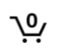 | The product added to the cart |  | PASS
4. | Click on cart icon | Cart page open | Cart page opened |  | PASS
5. | Check the product we added | The product we added shown | The product we added shown |  | PASS

TEST SCRIPT STEPS/RESULTS
STEP | TEST STEP/INPUT | EXPECTED RESULTS | ACTUAL RESULTS | Requirements Validated | PASS/FAIL
<Sanity Test> <functional negative Test>
1. | Open the app | The app run | The app run |  | PASS
2. | Click on search “mouse pad” | Navigate to results of mousepad page | Navigate to results of mousepad page |  | PASS
3. | Add product to the cart | The product will added to the cart | The product added to the cart |  | PASS
4. | Click on cart icon | Cart page open | Cart page opened |  | PASS
5. | Check if the product in cart the same product we added | The same product we added will shown | The same product we added will shown 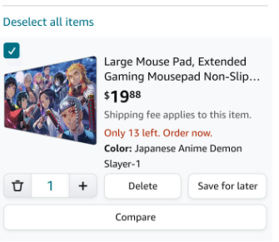 |  | PASS
6. | Check if the same product added to cart multiple times (4) | The count of the product in the cart will be 4 | The same product we added multiple times are now 4  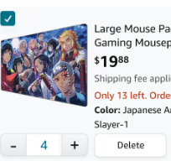 |  | PASS
6. | Check that the user is not able to proceed with negative numbers | The app will not allow the user to enter negative numbers | A dropdown table will shown and minimum number is (0 delete product) |  | PASS
7. | Check the editable of (plus +) button  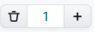 | The button is clickable and work | The button is clickable and work 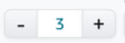 |  | PASS
8. | Check that the subtotal are change after adding same products 3times | Sub total for 1 product the same price of the product | Sub total is 3 times of the price for 1 product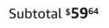 |  | PASS
9. | Check if the user click on the minus button until he receive 0 | Should delete the product from the cart | The product deleted from the cart |  | PASS
10. | Check subtotal of multiple deferent products | Subtotal of multiple products is the  (product 1 plus product 2)  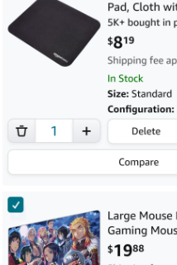 | The sum of both product are equal to the subtotal  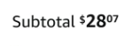 |  | PASS
11. | Check the cart after deleting all product (icon cart and subtotal) | The icon cart will be 0  And the subtotal will be 0 $ | The subtotal is disappear and the icon cart is 0 |  | PASS
12. | Check that the user can mark his order as a gift | The user can mark his order as a gift | The user can mark his order as a gift  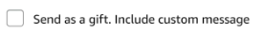 |  | PASS

TEST SCRIPT STEPS/RESULTS
STEP | TEST STEP/INPUT | EXPECTED RESULTS | ACTUAL RESULTS | Requirements Validated | PASS/FAIL
<Gui Test>
1. | Check the UI of the cart page design and paint | Every element are display with div and align | Every element are display with div and align The app run |  | PASS
2. | Check the compatibility of each elements | Each elements display in good and organized | Each elements display in good and organized |  | PASS
3. | Check the proofreading of cart page | The cart page has no spell error or different fonts | The cart page has no spell error or different fonts |  | PASS

Test Description: Amazon app test
<Testing the Localization of amazon app>
Test Purpose: <test Localization of Amazon app >
Test Run Instructions: <Describe any special instructions needed to execute this test (“Run” phase) >
Test Run Information:  Tester Name: sohayb saleh  Date of Test: 28/01/2024 | Prerequisites for this test: None
Software Versions:
Application: amazon mobile application
Browser: galaxy note 10+
Database: N/A
Operating System: android V12
Required Configuration: [ browser setup, security or user ID roles]
No special setup needed
NOTES and RESULTS:

TEST SCRIPT STEPS/RESULTS
STEP | TEST STEP/INPUT | EXPECTED RESULTS | ACTUAL RESULTS | Requirements Validated | PASS/FAIL
<Localization Test>
1. | Open the app | The app run | The app run |  | PASS
2. | Click on profile icon 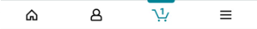 | Navigate to profile page | Navigate to profile page |  | PASS
3. | Click on flag icon in profile page   | Open country& language page | Open country& language page  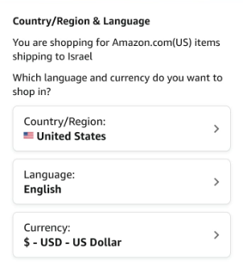 |  | PASS
4. | Change language to “arabic” | The will change from English to Arabic language | The will change from English to Arabic language 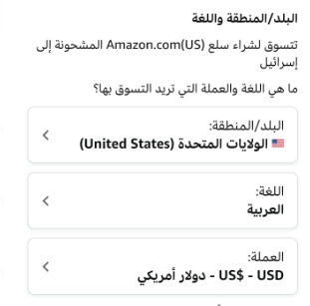 |  | PASS
5. | Change country from united state  To “المملكة العربية السعودية” 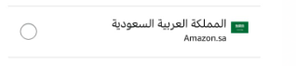 | The country will change to arabia saudi | The country changed to arabia Saudi  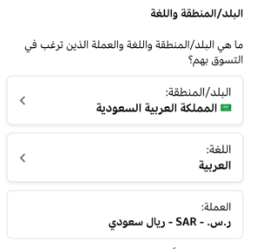 |  | PASS
6. | Check after changing the country is the currency is changed from dollar($) to Saudi Rial (SAR) | The currency is change | The currency has changed 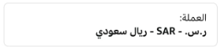 |  | PASS

